LIGHTNING/ STORM
DETECTOR

ABSTRACT:
The purpose of this project is to design a hand held battery operated device that will warn people of an approaching storm that contains lightning. This device will use the EMF amplitude modulated signal given off when lightning strikes. This signal is a very strong EMF one that can be partially detected using the same method as found in an AM radio. A lightning strike can actually be heard on the upper end of the AM dial (the quietest portion of the AM dial). Although it is very difficult to train the human ear to filter out all of the surrounding noise in order to hear the sudden spike. One would have to be listening constantly and very close in order to be sure that what they heard was indeed a spike caused from lightning. The device I will design can take this AM demodulated signal and pass it through yet another circuit that will warn the user in a light emitting fashion of an approaching storm. Future versions will consist of an audio warning also. The light emitting warning will consist of three different colored LED's in a bar graph type display. The green, yellow, and red lights will indicate the proximity of the storm. The audio warning will consist of three different tones that represent the proximity of the lightning strike.
Lightning is the most spectacular element of a thunderstorm. In fact it is how
thunderstorms got their name. Lightning is a giant spark. A single stroke of lightning can heat the air around it to 30,000 degrees Celsius (54,000 degrees Farhenheit)! This extreme heating causes the air to expand at an explosive rate. The expansion creates a shock wave that turns into a booming sound wave, better known as thunder. Thus the
name thunderstorm. Lightning can take place in several different areas of a thunderstorm. About 80% of all lightning occurs within a single cloud. Most of the other 20% occurs from cloud to ground. Sometimes lightning can jump from one cloud to another or to
the surrounding air. Most of the lightning we see appears as a single line of bright white light. However, there are several other types of lightning that can occur. These
include forked lightning, ribbon lightning, bead lightning, ball lightning,
sheet lightning, and heat lightning.

INTRODUCTION / HISTORY:
The reason I decided to design an early warning lightning/storm detector was due to a few close calls while fishing on a rather large lake. Yet another reason is due to the enormous amount of damage that can be done to unprotected electrical equipment. One who spends a lot of time outdoors hunting, fishing, camping, boating, hiking, or merely sight seeing will appreciate this low cost and easy to use hand held device.
Unpredictable weather has been on the rise in recent years, and will probably get worse as time goes on. This weather causes an estimated two billion dollars in lightning damage each year. With more surge sensitive equipment coming into everyday use, our world has become more susceptible to technological shutdown from lightning strikes. In addition to property damage, lightning strikes are dangerous to people. Over 200 people were struck and killed by lightning last year.
Today's early warning systems consist of expensive radar (such as Doppler), Global Positioning Satellite, and similar hand held microprocessor controlled devices. Although, the cost is very high for all the other devices and the need for a television or radio is required in order to use some of these devices. The hand held lightning/storm detector that I design will be much less expensive and very user friendly for any given situation.
The sky is filled with electric charge. In a calm sky, the + and - charges are
evenly interspersed throughout the atmosphere. Therefore, a calm sky has a
neutral charge. Inside a thunderstorm, electric charge is spread out differently. A thunderstorm consists of ice crystals and hailstones. The ice crystals have a + charge, while the hailstones have a - charge. The ice crystals are pushed to the top of the
thunderstorm cloud by an updraft. Meanwhile, the hailstones are pushed to the
bottom of the thunderstorm by its downdraft. Thus, the thunderstorm's + and -
charges are separated into two levels: the + charge at the top and the - charge
at the bottom. During a thunderstorm, the Earth's surface has a + charge. Because opposites attract, the - charge at the bottom of the thunder cloud wants to link up with
the + charge of the Earth's surface. Once the - charge at the bottom of the cloud gets large enough to overcome air resistance, a flow of - charge rushes toward the earth. This is known as a stepped leader. The + charges of the Earth are attracted to this stepped leader,
so a flow of + charge moves into the air. When the stepped leader and the +
charge from the earth meet, a strong electric current carries + charge up into
the cloud. This electric current is known as the return stroke of lightning and
is visible to the human eye.
Sound Waves vs. Light Waves:
You see a flash of lightning across the night sky. Five seconds later, your hear the rumble of thunder. If lightning and thunder come from the same source, then why don't they occur at the same time?
Actually, they do occur at the same time. The time difference that you sense is
due to the way sound and light travel. Light travels extremely fast (300,000,000
m/s). In fact, it is faster than anything else. Sound travels at a measly 343
m/s through air. Therefore we can see light in an instant, but it takes a while
to hear thunder. Sound has another disadvantage because it tends to bounce off molecules in the air. This makes the sound travel in all different directions. The further away
the source of the sound is, the more the sound gets distorted. Therefore, when you hear rumbling thunder, the lightning bolt was far away. When you hear a crack or boom of thunder, the lightning bolt is close to you (<100 m).

EVALUATION:
The in lab testing of the detector will be performed with a device that can generate an electric field. The simplest device would be a hot air gun or a hair dryer. These two devices generate a field similar to a lightning strike, although smaller in amplitude. Yet another device would be a Jacob's Ladder. The final testing should be done outdoors during an approaching storm after the device is calibrated on a clear day.

THEORY:
The idea behind this hand held detector consists of designing an AM demodulator, and using the output from this in order to drive some type of control circuit. The output of the control circuit will go to the input of a driver circuit. The output of the driver circuit will be used to illuminate ten LED's to let the user know how close an approaching storm is. See DIAGRAM 1 below.

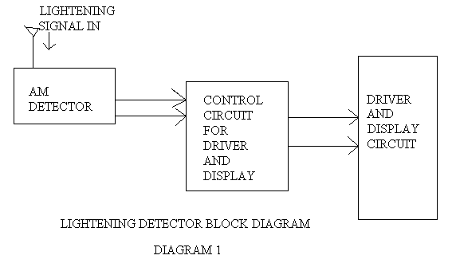

DESIGN:

The technology used for the AM demodulator (see figure 2 next on next page) will be based upon the monolithic linear integrated circuit LA1800. This device is an FM/AM single chip radio. I am using only the AM portion of the device. Although future versions will contain a fully equipped FM/AM radio in combination with the hand held detector. The input to the LA1800 will come from the lightning strikes waveform created by the sudden release of energy. This signal will be demodulated and then passed to the half-wave rectifier. The positive portion of the signal will be used as the input to the control stage of the detector. For additional information on the LA1800 see attached data sheet. The power supply for the AM detector circuit uses a 3 volt battery.

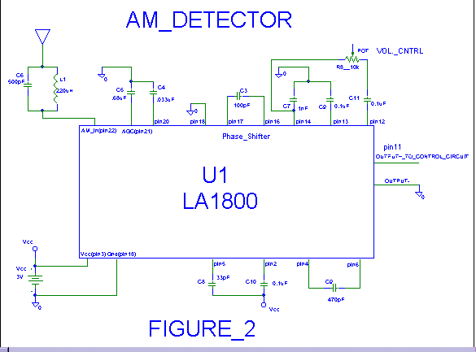

The control circuit design (see figure 3 on next page) will receive its input from the AM detectors output. If the user wants to hear the radio output signal, switch 1 is provided to switch the signal between the control, driver, and display circuit, to the speaker circuit. If the speaker is not being used R1 is provided to simulate the load on the AM detector output. The AM detectors output is then half wave rectified using D1. The signal at the output of the diode D1 is shown below in figure A. The half wave rectified DC output signal is then applied to C1 to charge it up. During the non charging portion of the half wave signal, C1 is discharged through R4 the 500K ohm pot. Since R4 is adjustable, the discharge rate of C1 can be set to match the audio characteristics of the particular radio signal being used. In this case I am using or tuning it to static(white background noise). The rate of discharge can be varied from almost instantly to approximately 5 seconds. Discharge rate = 10uF * 500k = 5 seconds or discharge rate = 10uF * 1 ohm = 10uSec.. Any where between 5 seconds and 10u seconds. Usually the AM detector output signal will hold the voltage on C1 steady with some fluctuation as the output signal gets louder and softer. When a pulse from a lightning strike surges through the AM detector, C1 charges much faster than it discharges. The voltage on C1 is then sensed by the next circuit which is the driver circuit.
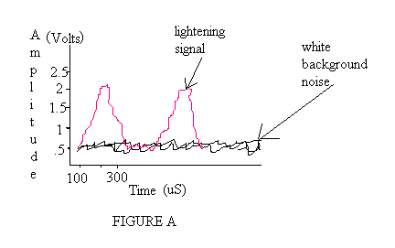

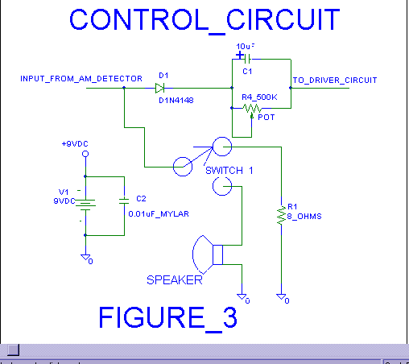

The driver circuit (see figure 4 below) is based on the LM3914 Dot/Bar Display Driver. This chip is designed to show a voltage reading on a set of light emitting diodes. Within the LM3914 are a voltage divider network and ten comparators that turn on in sequence as the input voltage, from the control circuit, increases. The LM3914 can display the voltage level as a bar of LED's or as a single moving dot. I have designed the LED display to be a bar display. The LED's are three different colors. The four green ones indicate a safe condition or that an approaching storm could be between approximately 30 miles away to 15 miles away. The three yellow ones indicate caution or that an approaching storm is between 15 miles to 6 miles away. The three red ones indicate danger or that an approaching storm could be between 6 miles away to 1 mile away and the user should take shelter immediately.
The power supply for this circuit is a 9 volt battery, although any source between 5 and 18 volts will work. If the circuit is to be left on for long periods of time an external power source is recommended. This is because if the voltage source should drop below the LM3914's minimum supply requirement the comparators within the IC will not be very reliable. For additional information on the LM3914 see attached data sheet.

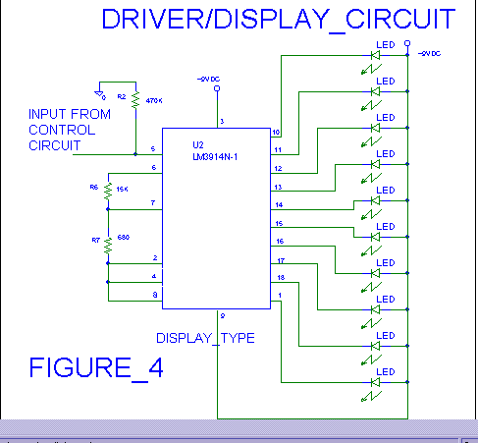

PARTS LIST:

Part | Part
Label | Description | Qty.
R1 | 8 OHM 5% CARBON | 1
R2 | 470K OHM 5% CARBON | 1
R4 | 500K OHM POT 10% | 1
R6 | 15K OHM 1% METAL FILM | 1
R7 | 680 OHM 1% METAL FILM | 1
R8 | 10K POT 10% | 1
C1 | 10uF ELECTROLYTIC | 1
C2 | 0.01uF MYLAR 10% | 1
C3 | 100pF | 1
C4 | 0.033uF | 1
C5 | 0.68uF | 1
C6 | 500pF | 1
C7 | 1nF | 1
C8 | 33pF | 1
C9,C10,C11 | 0.1uF | 3
LED 1-10 | LIGHT EMITTING DIODE | 10
L1 | INDUCTOR | 1
D1 | 1N4148 SMALL SIGNAL | 1
SW 1 | SPST | 1
SPEAKER | 8 OHM | 1
BATTERY | 9 VDC | 1
BATTERY | 3 VDC | 1
U1 | LA1800 AM/FM CHIP | 1
U2 | LM3914 DISPLAY DRIVER | 1

CONSTRUCTION:
The lightning detector circuit can be built on two pieces of perfboard using the necessary wire and components. The AM detector circuit should be built on one piece of perfboard and the connection between the AM detector circuit and the other piece of board should be as short as possible. The control circuit and the display/driver circuit should be built on the other piece of perfboard with all connections as short as possible to reduce any type of interference. The size of the LED's should be large enough to be visible from approximately 10 feet away. Again all connections should be as short as possible. The device can be put in a any casing that shields RF energy. The antenna for the design should be one that will pick up AM and eventually FM signals. I used an old antenna from a small hand held portable AM/FM radio.

CALIBRATION AND TESTING:
I have designed my circuit to the upper end of the AM band, approximately 1700KHZ. This is the quietest part of the AM band. On a clear day power up the device and set the speaker switch on to verify that the output is somewhat quite white noise. Next switch the speaker to off and make sure that the speakers output is disabled. If this works up to hear find some type of source that generates static. A hot air gun will work well for this. Next set the volume control so that the output makes all of the LED's light when the lightning source (hot air gun)is about one foot away from the detector Next adjust the potentiometer so that the LED's display will fade out in a time interval that is reasonable enough for the user to notice the simulated strike. A second or two should be sufficient. Then move the hot air gun (lightning source) slowly away from the detector and verify that the display goes from the red LED's lighting to the green ones lighting as the lightning source gets farther and farther away.
On a day when there is a storm in the area repeat the above procedure using an automobile, to follow the storm, and a second person to make the adjustment to the potentiometer. This may take some time (a couple of months up to a couple of years) to calibrate the device depending upon the distance of the storm and the strength of the lightning strikes signal. In addition to the number of storms in the area.

CONCLUSION:
The device worked great in the laboratory using a hot air gun as the source of static. The proximity problem worked in the lab at a distance of one foot away as a close lightning strike and up to about 50 feet away as a distant strike. When the device was about one foot away the entire row of LED's was illuminated, and as the source of lightning was moved farther and farther away the LED's went from the red to the yellow and eventually the green being the only ones illuminated.
When the device was tested during a storm it worked well for lightning strikes that were at a distance from one mile away up to approximately 10 miles away. At a distance of ten miles away the last green LED and the first yellow LED was illuminated.
At a distance greater than ten miles away the last green LED was the only one illuminated.
So, overall I would say the project was a success. With the exception of distances
greater than ten miles away the row of green LED's stayed illuminated. The project was very time consuming as far as the testing and calibration were concerned. I spent many months waiting for the proper weather conditions to appear.
I have spent time on future designs which include the collection and analysis of lightning signals. These signals will be analyzed using DSP technology along with microprocessor technology in order to more closely predict the distance of a storm.

